Revision of Structured Programming
LAB # 00


Fall 2025
CSE208L Object Oriented Programming Lab

Submitted by: Muhammad Mohsin Khan
Registration No.: 24PWCSE2382
Class Section: C

“On my honor, as student of University of Engineering and Technology, I have neither given nor received unauthorized assistance on this academic work.”

Student Signature: ______________

Submitted to:
Engr. Sumayyah Salahuddin
September 22, 2025

Department of Computer Systems Engineering
University of Engineering and Technology, Peshawar
Objectives of the Lab:
- Reinstate the concepts of structured programming such as:
  - Decision making
  - Iterations
  - Functions
  - Structures and arrays
  - Pointers

Activity # 0.3.1
Title:
Write a C++ program that calculates the average of a set of numbers entered by the user.
Source Code:
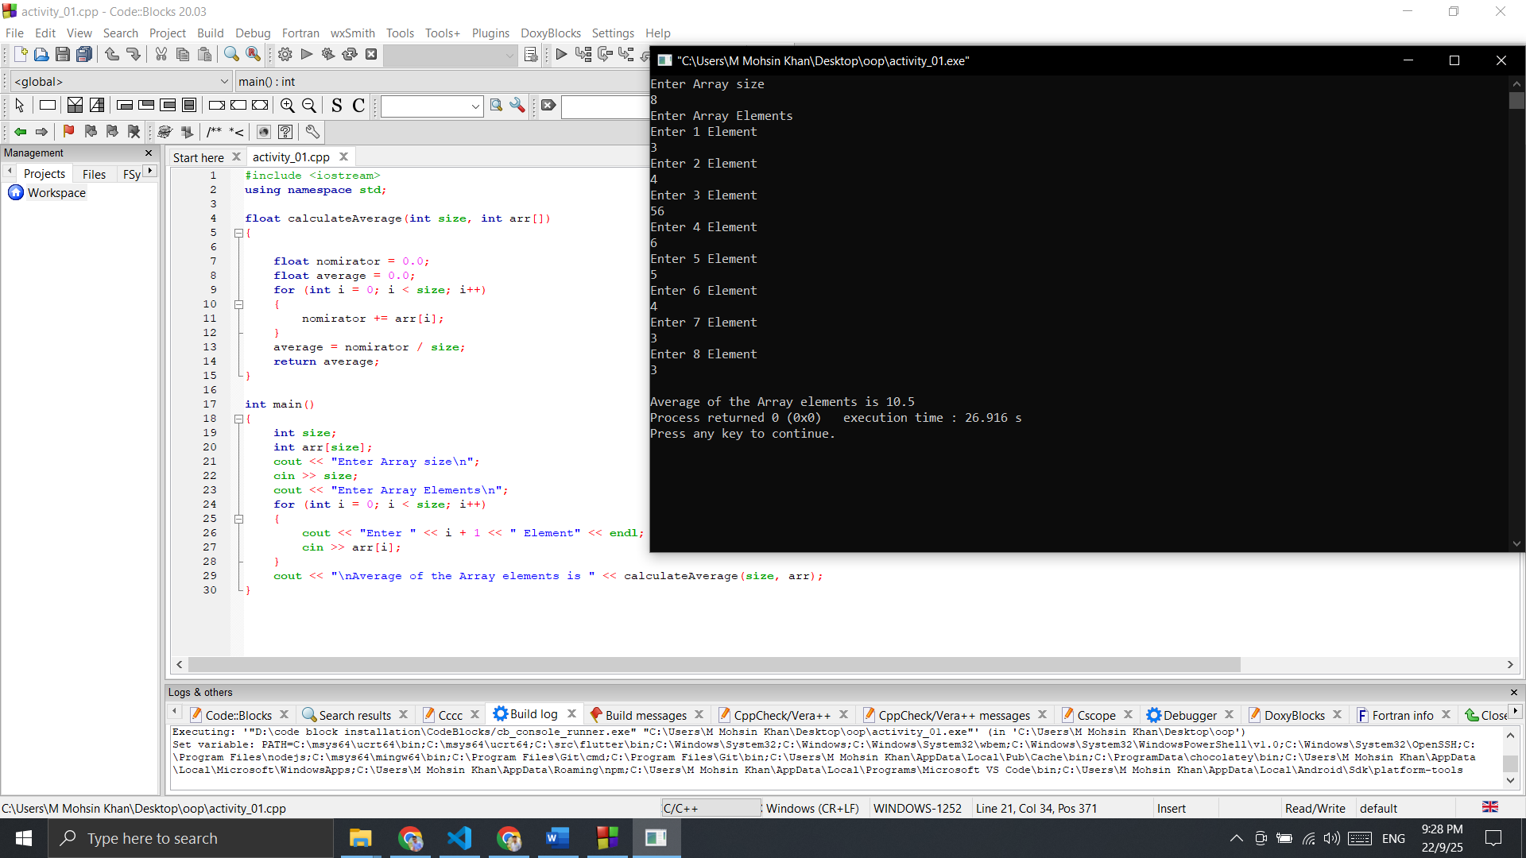
Output:
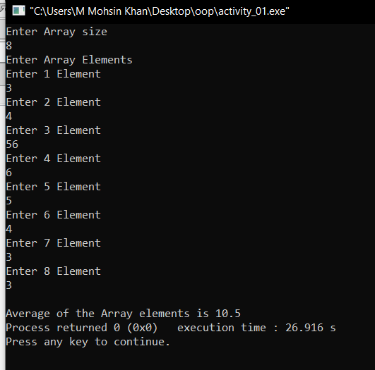

Activity # 0.3.2
Write a program that creates Student structure.
Source Code:
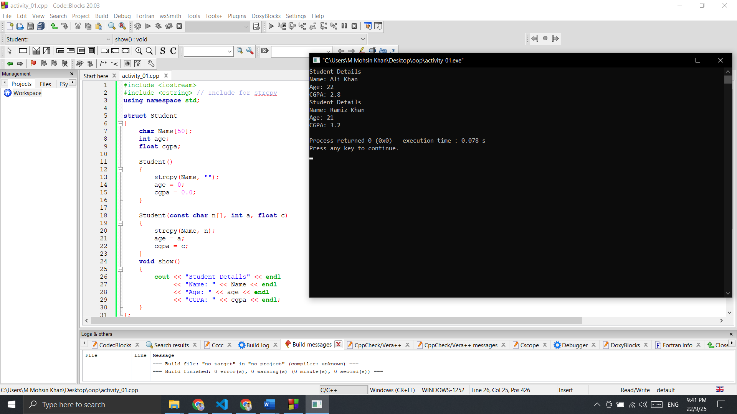
Output:



Activity # 0.3.3
Write a C++ program that generates random data and calculates the sum of the generated data.
Source Code:
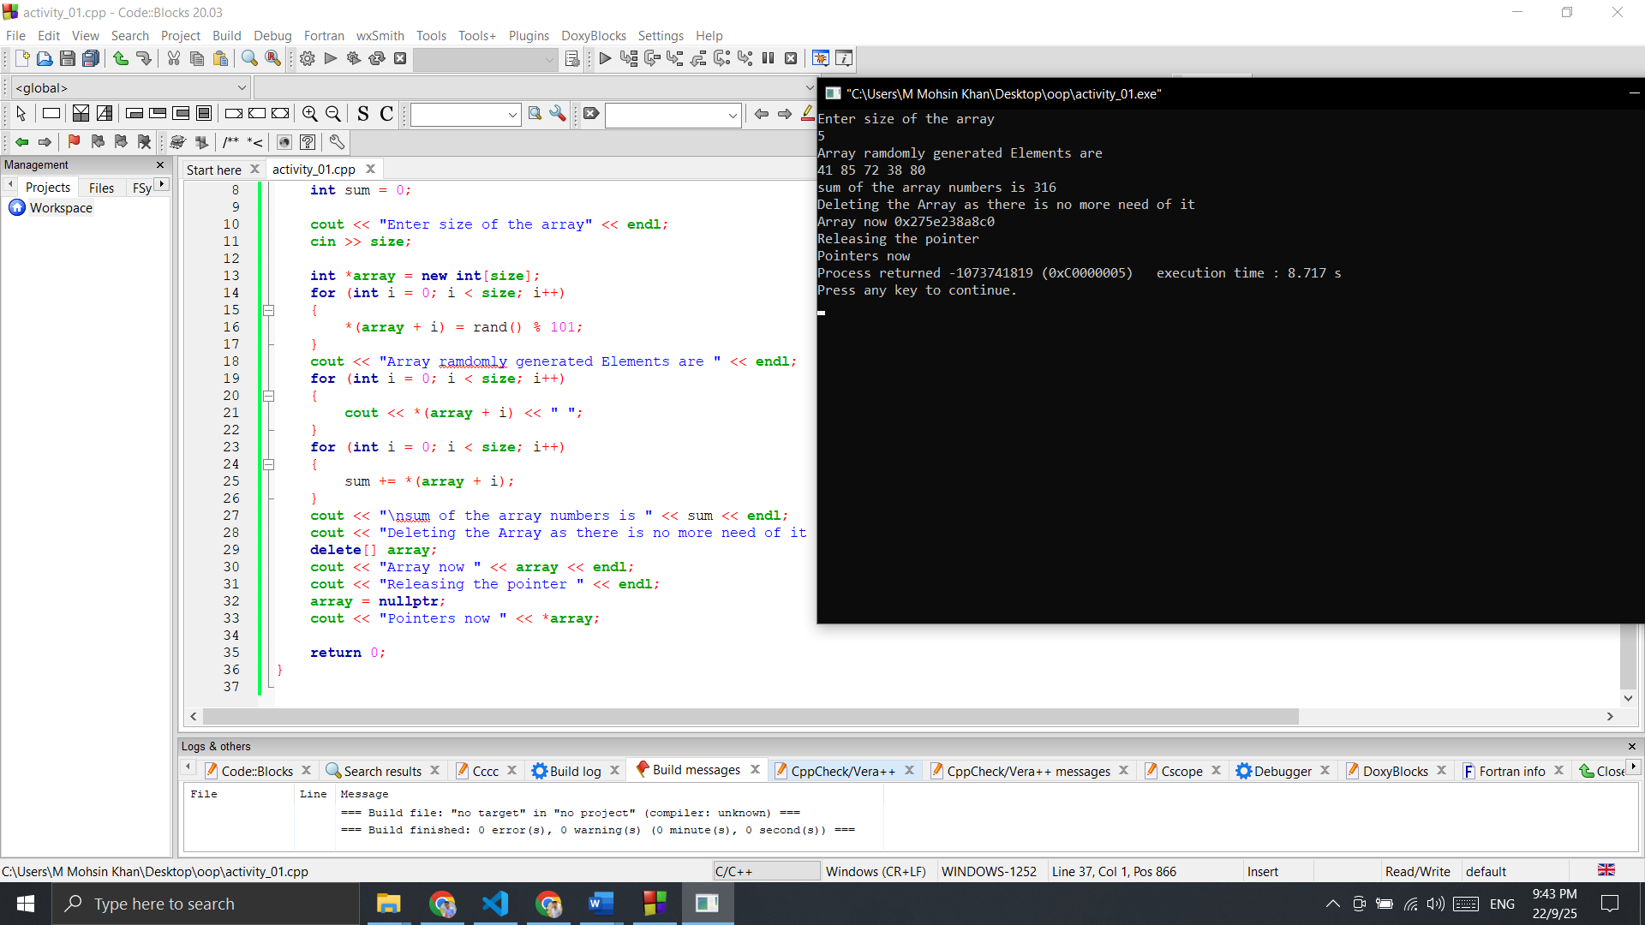
Output:


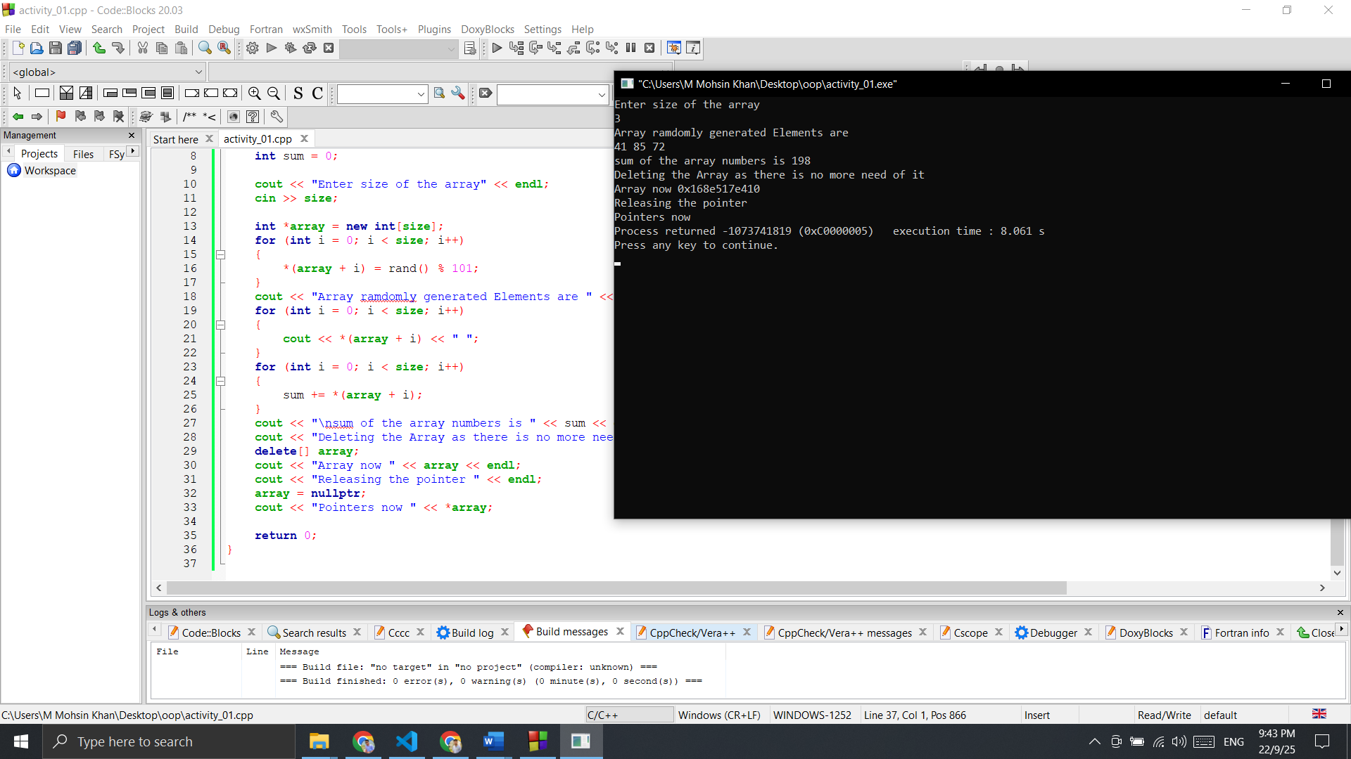

Activity # 0.3.4
Write a C++ program to find transpose of a NxN matrix. Declare integer matrix and its transpose using calloc () (use #include <cstdlib>). Use 2D pointers in this activity for storage, retrieval, and finding transpose. Free the pointer variables in the end.

Source Code:
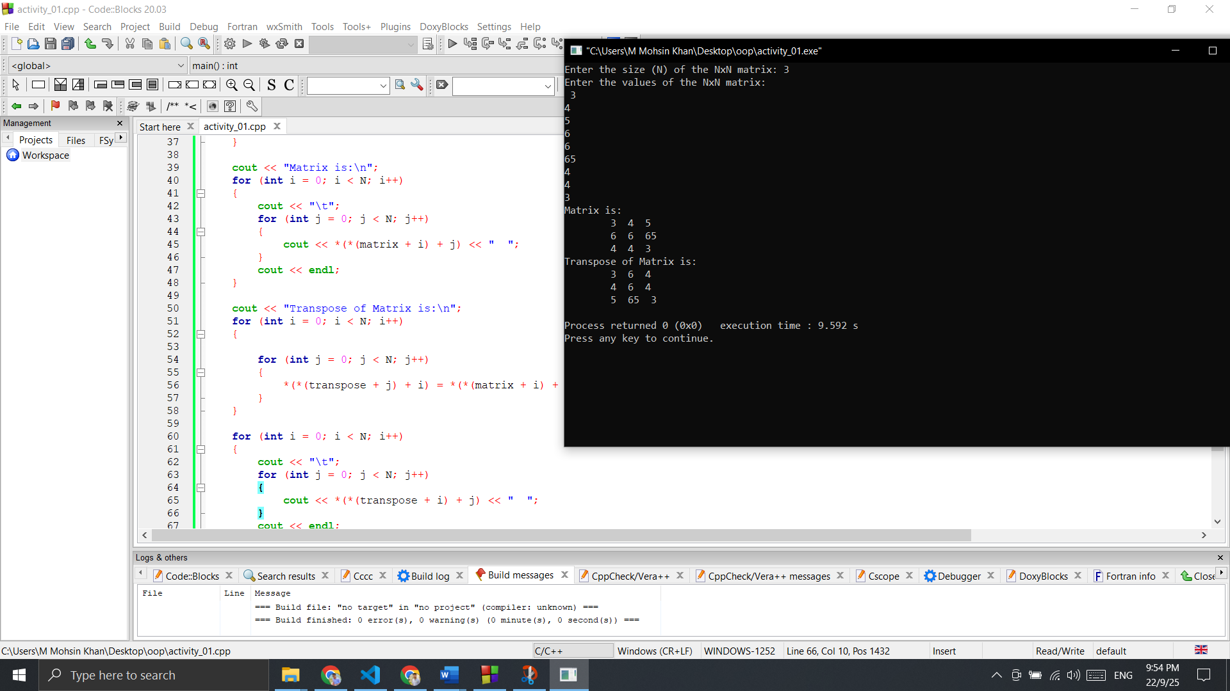
Output:



